

**Election 2018: Candidate Information Session**

**Workforce Development**

**Policy Issue #1:** Howard County has a need for additional middle skill *family supporting* jobs.

*Background*

* These jobsrequire education more than a high school diploma, but less than a bachelor’s degree. Some require an occupational license or certification. According to the Baltimore Metropolitan Council these jobs lead to a family supporting wage in our region.
  + Examples, in Howard County, of the top family-supporting occupations that will be in demand over next ten years 2016-2026: heavy and tractor trailer truck drivers; bookkeepers, accountants, and auditing clerks; tradesmen (carpenters, electricians, plumbers, HVAC specialists); computer user support specialists; licensed practical nurses.
* Based on the Baltimore Metropolitan Council’s findings, family supporting jobs are jobs that pay $22.28/hour. This wage is for the Baltimore Region.
  + **Median Hourly Earnings by Educational Attainment**

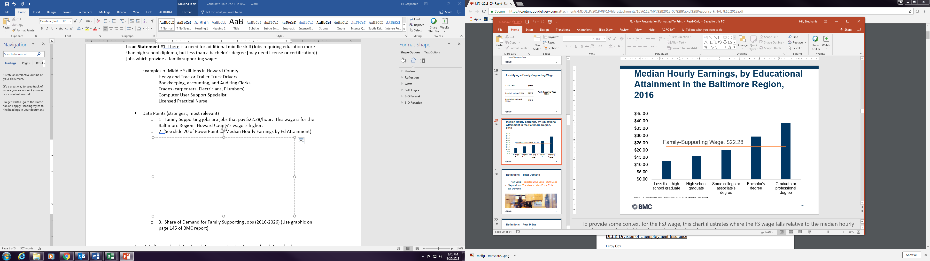

* 42,814 jobs are family supporting jobs in Howard County; this constitutes 18.6% of the total demand in the region. This is the highest share in the region but there is still a need.
* A worker’s wages are generally tied to the level of educational attainment. Higher levels of education open increased job opportunities and increased pay.
* Earnings gradually increase from $12.50/hr for those without HS diploma to nearly $40.00 for those with a graduate level or professional degree.

**Howard County Share of Demand for Family Supporting Jobs (2016-2026)**



A close up of a sign with a mountain in the background

Description generated with high confidence

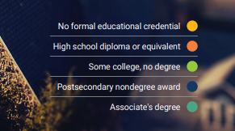

*Policy opportunities to address issue*

* Some individuals working low wage jobs may not be eligible based on family income guidelines. County/State/ sector should Identify mechanisms to assist individuals that fall above eligibility guidelines but still may not be earning a family supporting wage.
* Strengthen the region’s economy by securing Howard County’s share of family-supporting jobs by providing incentives for businesses to create middle-skilled jobs.

**Policy Issue #**2: Apprenticeship is an underused business model that can fill the skills gap for business and create more family supporting job opportunities.

*Background*

* According to the US Department of Labor, apprenticeship is a proven approach for preparing workers for jobs while meeting the needs of business for a highly-skilled workforce. It is an employer-driven, “learn-while-you-earn” model that combines on-the-job training provided by the employer with job-related instruction in curricula tied to the attainment of national skills standards. Apprenticeships are not limited to trade skill jobs, but also are available for occupations such as management and information technology. The model also involves progressive increases in an apprentice’s skills and wages.
* Responding to increasing employer need, apprenticeships in Maryland have grown by 15% from 8441 to 9718 since July 2016.
* Howard County had 252 active apprentices as of December 31, 2017.

*Policy opportunities to address issue*

* Encourage businesses to apply for funding through the State Department of Labor’s Innovation fund for new and innovative apprenticeship models.
* Continue support for the state Apprenticeship tax credit thru which employers may be eligible to claim $1,000 per new Registered Apprentice per year.

**Policy Issue #**3: Childcare costs may not be affordable for those earning less than a family supporting wage. At a family supporting wage the cost is challenging without supplemental financial support.

*Background*

According to the Maryland Family Network 2016 Childcare Demographics report average annual cost for center-based care:

Infants - $19,150

2-4-years old - $13,555

School aged children - $6502

Unaffordable childcare affects the business community, and has a significant impact on workforce participation and is a drain on US employers’ bottom lines. With affordable, accessible care, employers report fewer absent workers, less turnover, increased stability in the workforce, and more satisfied workers (Childcare Aware of America’s, 2017 Report *Parents and the High Cost of Childcare*)

*Policy opportunities to address issue*

Consider expanding after school care to include evening and weekend hours for individuals working those shifts.

Encourage businesses to create childcare facilities, that accommodate shift workers in County employment centers. Give priority to employees of those businesses.

Support continued funding for Head-Start. Introduce Early Head Start programs for infants and toddlers. This creates the opportunity for more low-income workers to enter the job market.

**Additional Background**

* U. S. Department of Labor *Apprenticeship Toolkit*

<https://www.dol.gov/apprenticeship/toolkit/toolkitfaq.htm>

* Maryland Department of Labor and Licensing *Apprenticeship and Training Program* <https://www.dllr.state.md.us/employment/appr>
* Baltimore Metropolitan Council *Family Supporting Jobs Report*, July 2018

<https://us9.campaign-archive.com/?e=&u=493e651c623ae7f4e8fc6a027&id=db4027832f>